Question 1
Ans:
- Immersion lens configuration is better to get high resolution image because
- In immersion lens the focal length are very small in the order of 1mm to 4mm. Because lens aberration scale with focal length, this design yields the lowest aberrations, the smallest probe size, and the highest resolution
- Collection of SEs in the lens takes advantage of that the SEs can spiral upward in the strong magnetic field to the detector above the lens.
Question 2
Ans:
- If we want to observe all the regions of the fracture surface
- The working distance should not be too small (it affects the depth of focus).
- The spot size should be moderate (it covers the wide area)
- Inter mediate beam energy.
- The effect of working distance on resolution:
- Increasing of working distance producing the larger spot size at specimen and consequently degradization of the image resolution.
- The effect of aperture size on resolution:
- The aperture size decreases the beam angle from higher value to lower values for the electron entering into the objective lens.
- The final aperture size affects the final electron probe size and final probe size related with resolution.
Question 3
Ans:
SE1 and SE2 energy in the order of 0-50eV
We can eliminate the affect of SE1 and SE2 by negative biasing (-150 to -200V) the E-T detector.

Question 4
Ans:
- Probe current for imaging in SEM typically between 10 pico amps to 1nano amps
- Sources to get higher current:
Tungsten filament – 100micro amps
LaB6 - 1-10micro amps
Question 5
Ans:
- Accelerating voltage:
- The size of the interaction volume is a strong function of the energy with which the beam electron interacts with the target.
- First, the cross section for elastic scattering has an inverse dependence on square of the energy Qα1/E2 . Thus, the beam energy increases electron trajectory more straight and penetrate deeply into the solid
- Second, the rate of energy loss with distance traveled is inversely related to the energy E. As the beam energy is increased, the electron can penetrate to greater depths because they enter the specimen with more energy and lose it at a lower rate.
- Influence of atomic number on the interaction volume:
- At constant beam energy the dimensions of interaction volume decreases with increasing atomic number.
- The scattering cross section Q proportional to square of the atomic number Z

Question 6
Ans:
Angstrong level resolution should not possible practically
- Reasons: The lens suffer from aberrations and aperture diffraction
- Explanation:
- Spherical aberration:
Spherical aberration disk of least confusion diameter
d_{s} = 1/2C_{s}α³
Cs is spherical aberration coefficient
α is the angle of the outer ray through the lens.
The contribution of ds to final probe diameter can be reduced by limiting α with an objective lens aperture.
Unfortunately, very small aperture reduces the current in the probe and introduces aperture diffraction.
Aperture diffraction:
For very small aperture, the wave nature of electron gives rise to a circular diffraction pattern.
Spot size d_{d} =0.61λ/α
For aperture diffraction, the larger value of α , the smaller will be the contribution dd. Thus, spherical aberration and aperture diffraction vary in opposite direction with respect to α.
Question 7
Ans:
- E-T Detector with Negative bias:
- The negatively biased ET detector collects only the BSE and all SE are rejected.
- High energy BSE that leave the specimen with trajectories directly toward the face of the scintilator are collected all other BSE emitted from the specimen is lost.
- At zero degree tilt , 0.05Sr solid angle and take of angle at 30 degrees give the geometrical efficiency about 0.8% and it is very less to collect the BSE.

- E-T Detector with positive bias:
- The positively biased ET detector attracts from the specimen over a much wider range of solid angle into the detector.
- Calculations of the trajectories of SE under the positive field of the ET detector reveal the SE can be collected even if there is not direct line of sight from the specimen to detector. From a flat surface , the collection efficiency can approach 100%.

Question 8:
Ans:
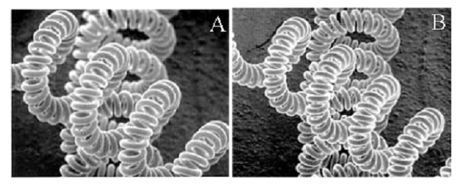
In both the case only one parameter is varied that is working distance.
Larger working distance me high depth of focus.
In figure B depth focus is more and we can observe the base of the filament very clearly compare with Fig A.

